Vadim Bykov.

Hello! I am a beginner programmer with a great desire to work, develop and benefit your company. Decent, punctual and responsible.

Basic Information

1. Name: Vadim Bykov
2. Address: 18 Gogol Lane, Mogilev, 212011, Belarus
3. Date of birth: 19 September 1981
4. Nationality: Belarusian
5. Marital status: married
6. Language: Native Russian, English (passed the test at EPAM Training Portal, level A2)
7. Education:

2020-2021 **RS-School**, the Rolling Scopes course «JavaScript/Front-end». [CERTIFICATE](https://app.rs.school/certificate/sn65vfub).

2007-2011 Mogilev State University of Food, department of Automation of Technological Processes and Production

1997-2001 Mogilev Chemical-Technological College, department of Electrical Power Engineering

1. Сurrent workplace, position: Plant "Mogilevtransmash" OJSC "MAZ" - the managing company of the holding "BELAVTOMAZ", Deputy Chief Power Engineer
2. Programming skills: HTML5, CSS3, SASS, JavaScript, React, Redux, TypeScript, Axios, Webpack, ESLint, Git, Debugging, Figma.

### *My works:*

### Travel app

### image

React (TypeScript) Application with information for tourists

Task: <https://github.com/rolling-scopes-school/tasks/blob/master/tasks/react/travel-app.md>

Deploy: <https://vadim-bykov.github.io/travel-app/>

### React game

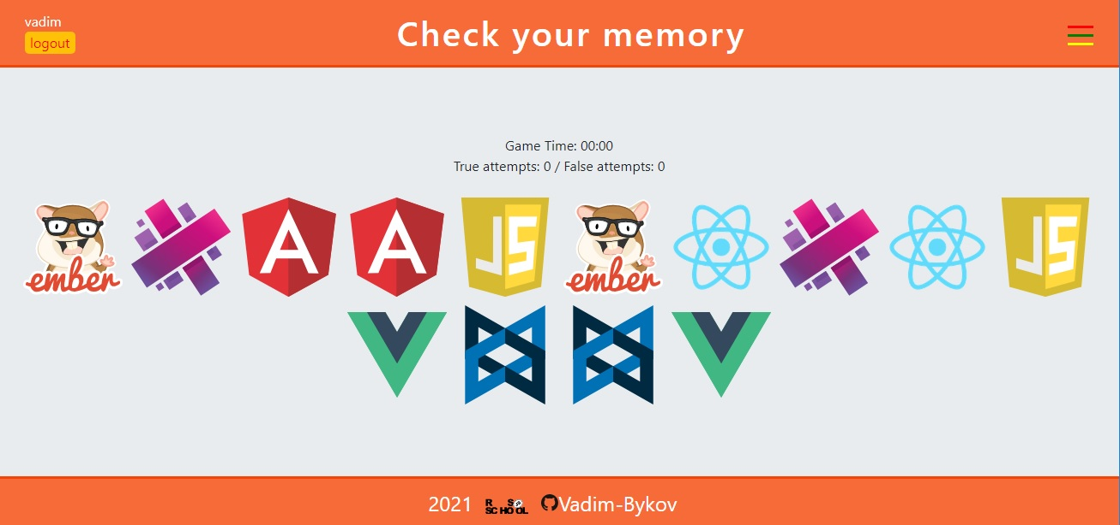

React application to check your memory

Task: <https://github.com/rolling-scopes-school/tasks/blob/master/tasks/react/react-game.md>

Deploy: <https://vadim-bykov.github.io/react-game/>

### COVID-19 Dashboard

### image

Application for tracking the spread of COVID-19 in the world and in selected countries

Task: <https://github.com/rolling-scopes-school/tasks/blob/master/tasks/covid-dashboard.md>

Deploy: <https://rolling-scopes-school.github.io/vadim-bykov-JS2020Q3/covid-dashboard/dist/index.html>

### English for kids

### image

English learning app for kids

Task: <https://github.com/rolling-scopes-school/tasks/blob/master/tasks/rslang/english-for-kids.md>

Deploy: <https://rolling-scopes-school.github.io/vadim-bykov-JS2020Q3/english-for-kids/>

### Gem-puzzle

### image

The goal of the game is to move the tiles around the box to arrange them by numbers.

Task: <https://github.com/rolling-scopes-school/tasks/blob/master/tasks/gem-pazzle/codejam-the-gem-puzzle.md>

Deploy: <https://rolling-scopes-school.github.io/vadim-bykov-JS2020Q3/gem-puzzle/dist/index.html>

### Virtual keyboard

### image

A project to create a multifunctional virtual keyboard.

Task: <https://github.com/rolling-scopes-school/tasks/blob/master/tasks/ready-projects/virtual-keyboard.md>

Deploy: <https://rolling-scopes-school.github.io/vadim-bykov-JS2020Q3/virtual-keyboard/>

### Shelter

### image

The task of creating a page according to the layout. There are burger menu, slider, popup.

Task: <https://github.com/rolling-scopes-school/tasks/blob/master/tasks/markups/level-2/shelter/shelter-DOM-ru.md>

Deploy: <https://rolling-scopes-school.github.io/vadim-bykov-JS2020Q3/shelter/pages/main/main.html>

### Momentum

### image

Momentum is an analogue of the app of the same name in the Chrome web store. The application shows the time and username, his goal for the current day. The background image changes depending on the time of day. The application uses local storage to store data.

Task: <https://github.com/rolling-scopes-school/tasks/blob/master/tasks/ready-projects/momentum.md>

Deploy: <https://rolling-scopes-school.github.io/vadim-bykov-JS2020Q3/momentum/>

### Calculator

### image

Calculator is my first project where I started working with JavaScript.

Task: <https://github.com/rolling-scopes-school/tasks/blob/master/tasks/ready-projects/calculator.md>

Deploy: <https://rolling-scopes-school.github.io/vadim-bykov-JS2020Q3/calculator/>